Собрание лабораторных работ по машинному обучению.
ЛР 1.
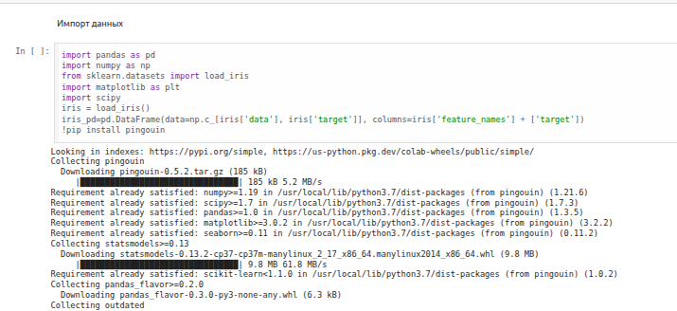
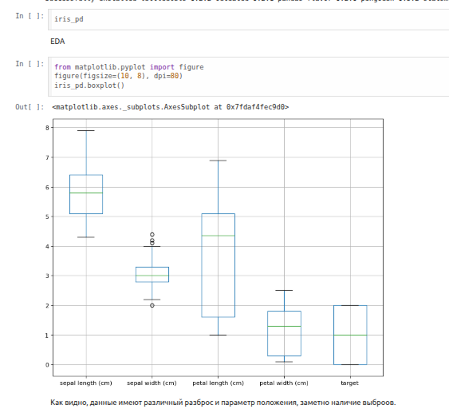

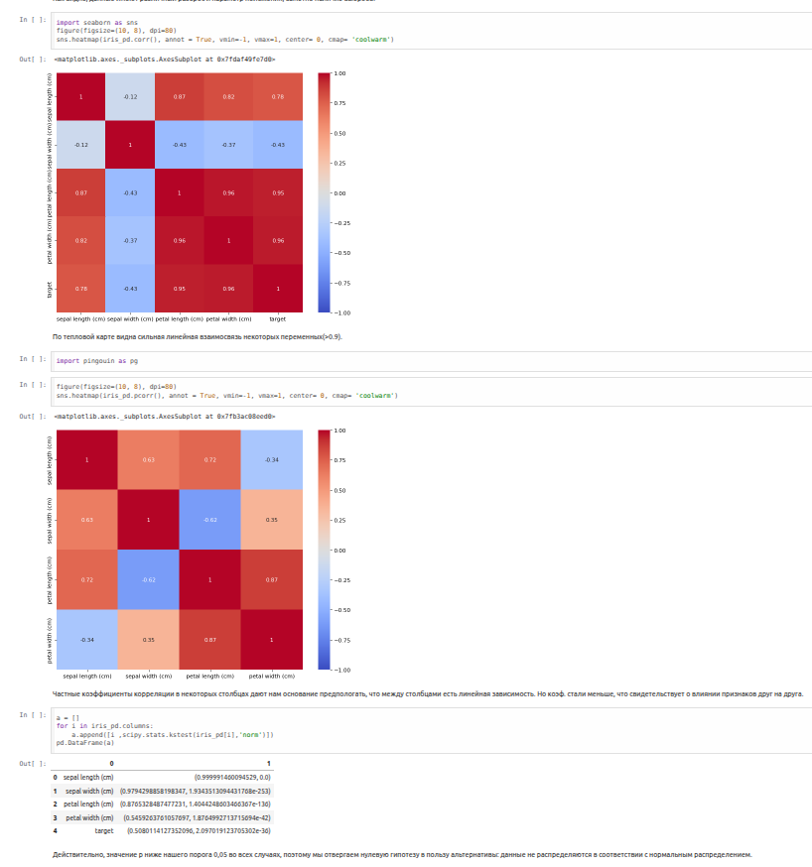

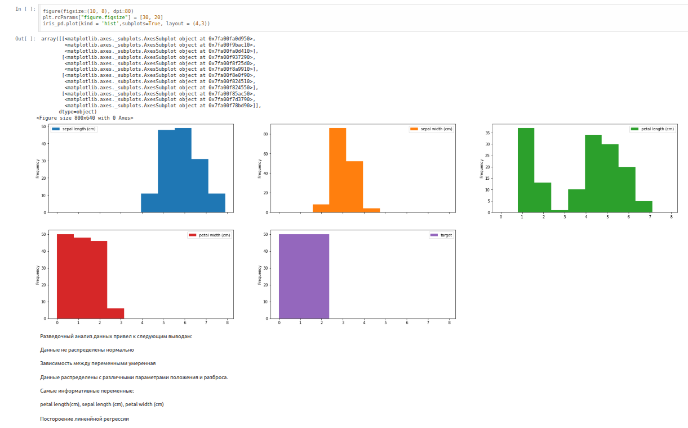
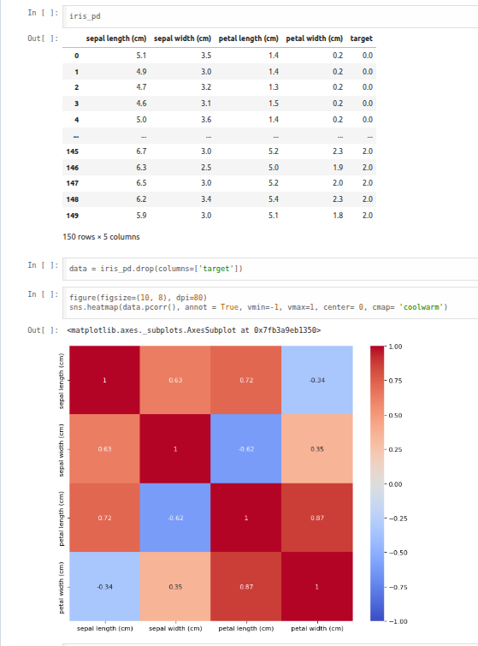

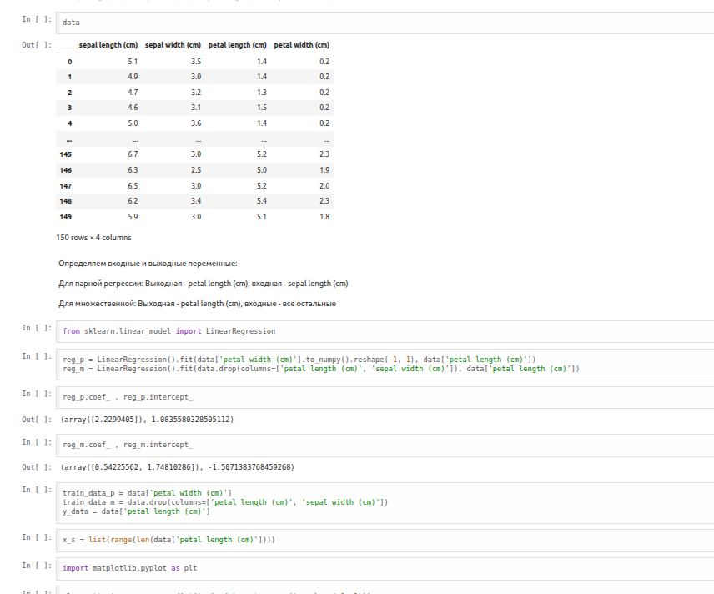
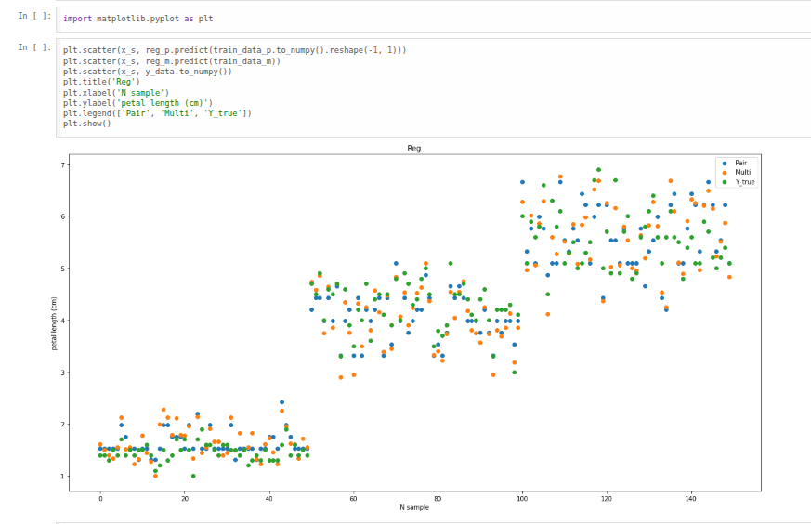

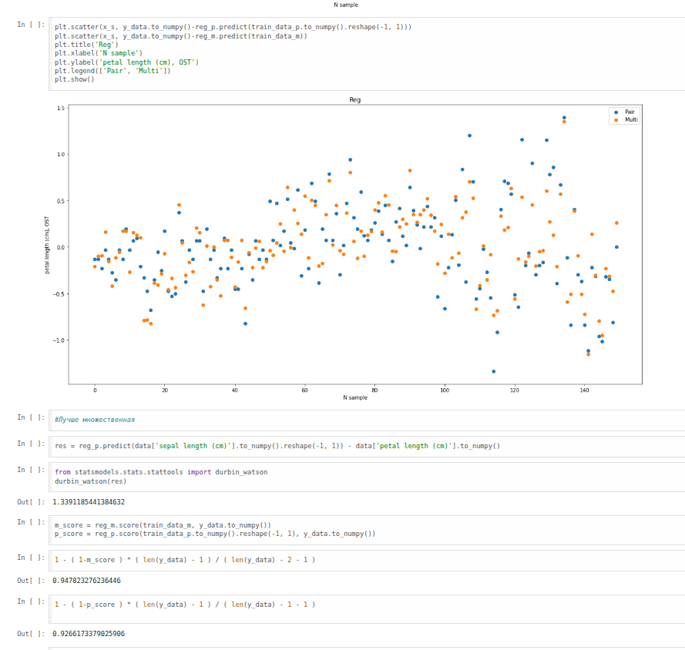
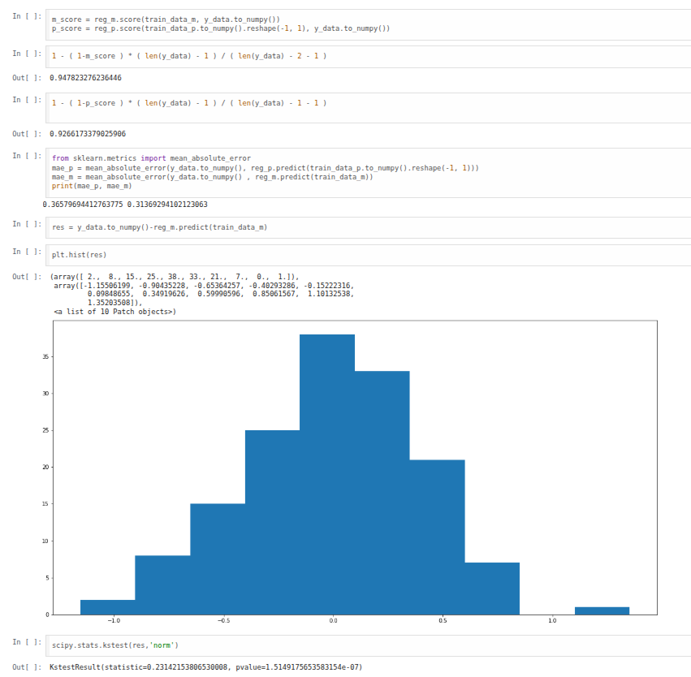
ЛР 2.
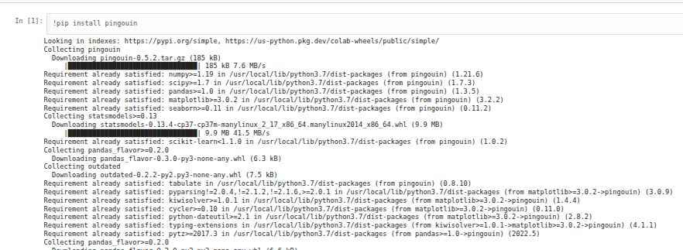

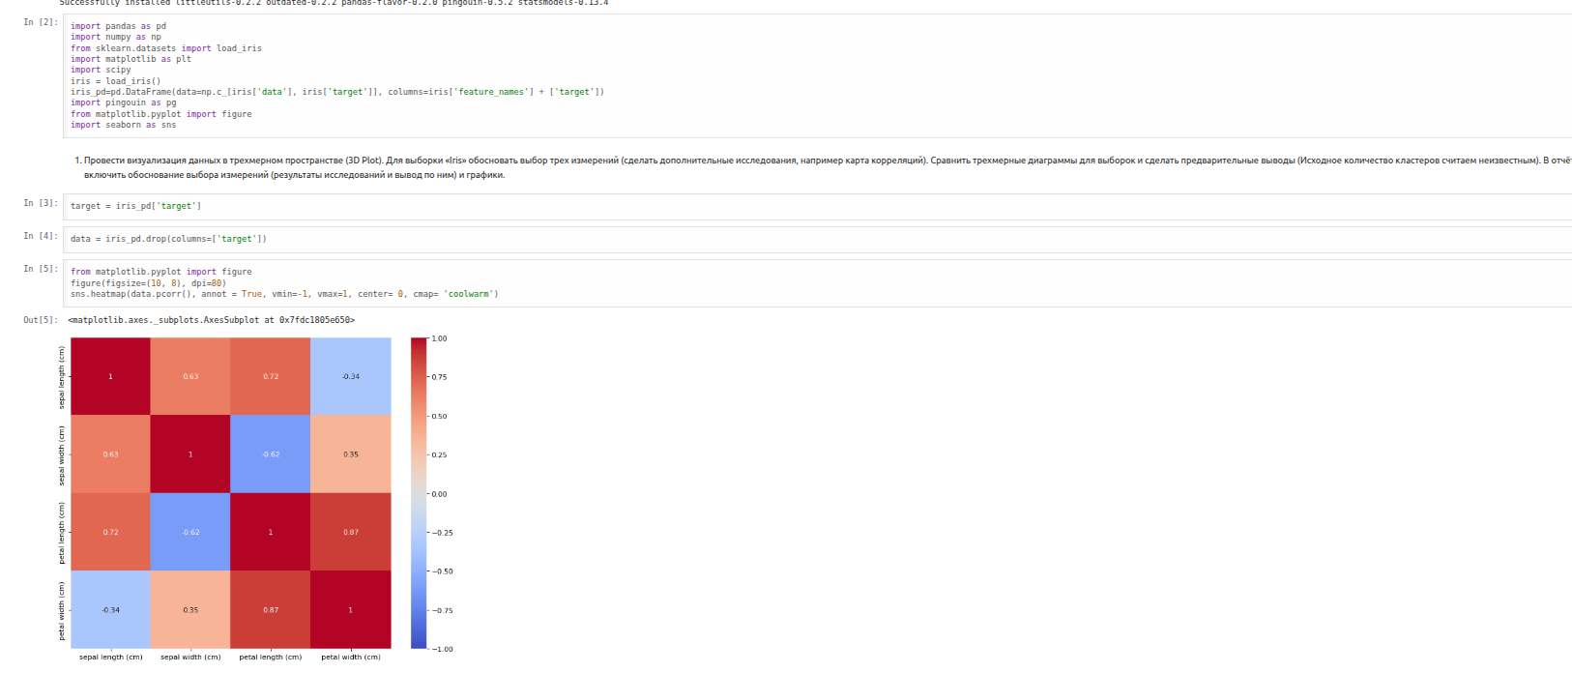

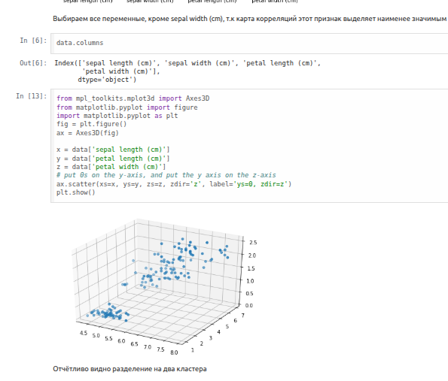

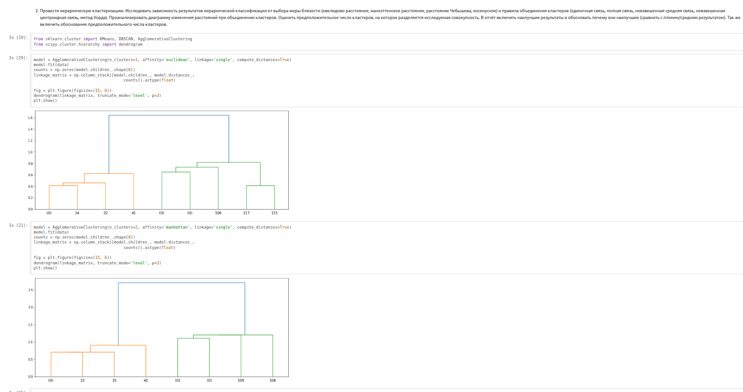

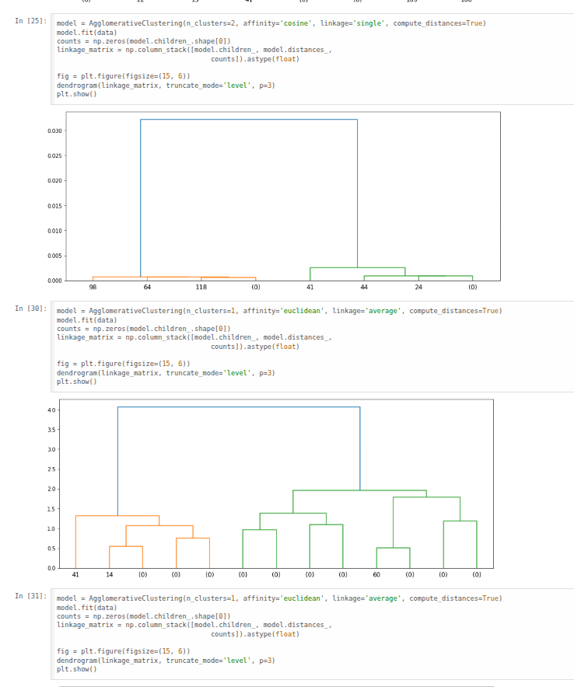

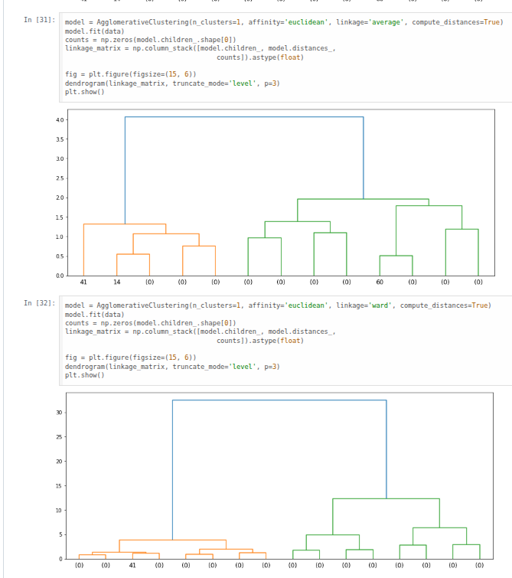

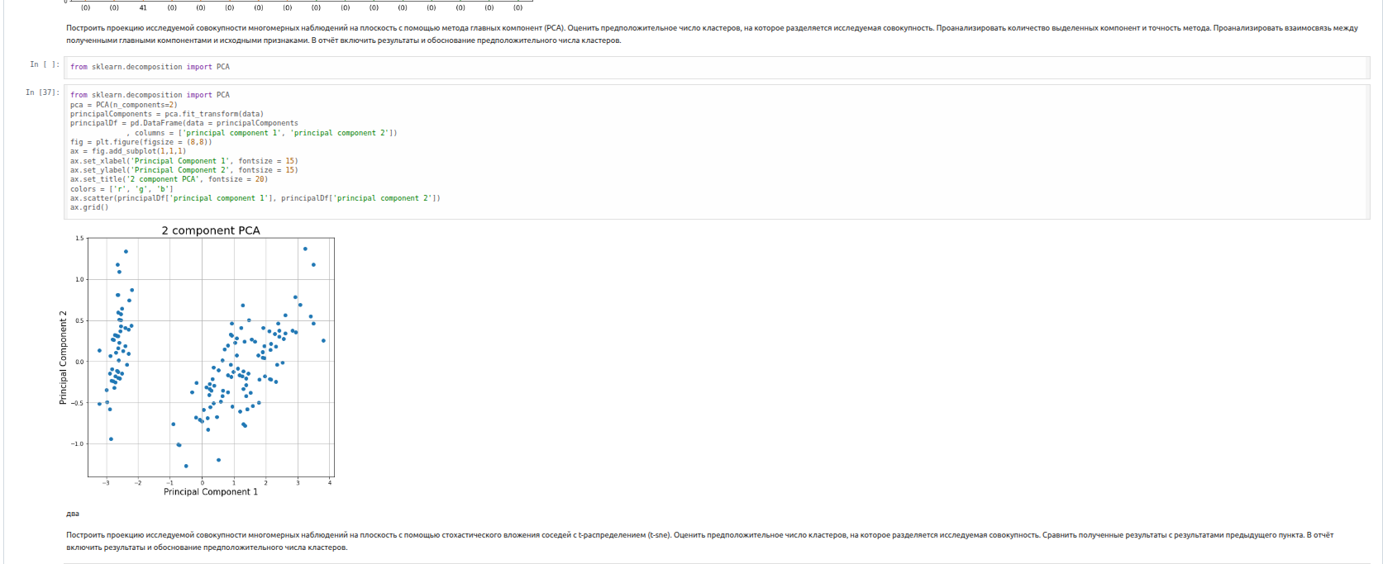
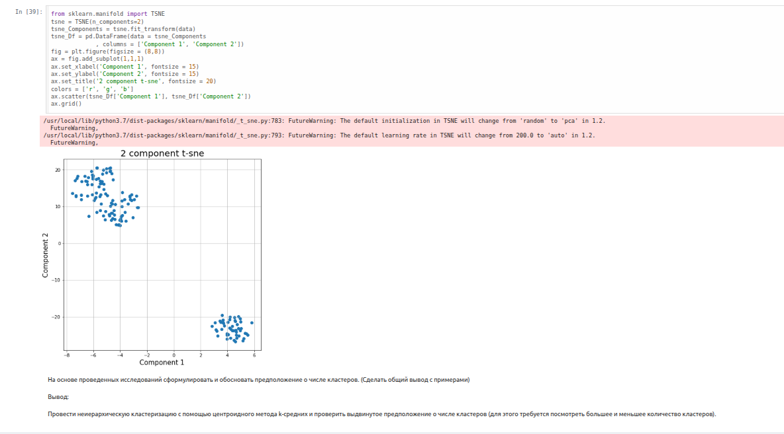

ЛР 3. Ирисы Фишера.
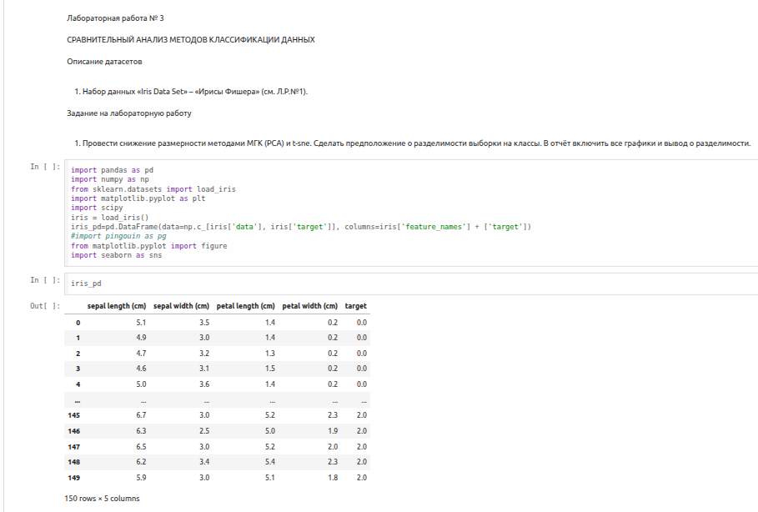

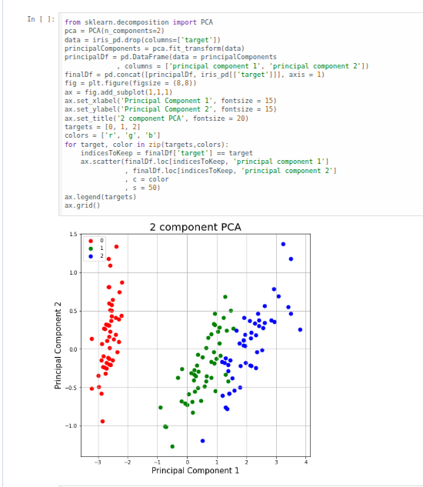

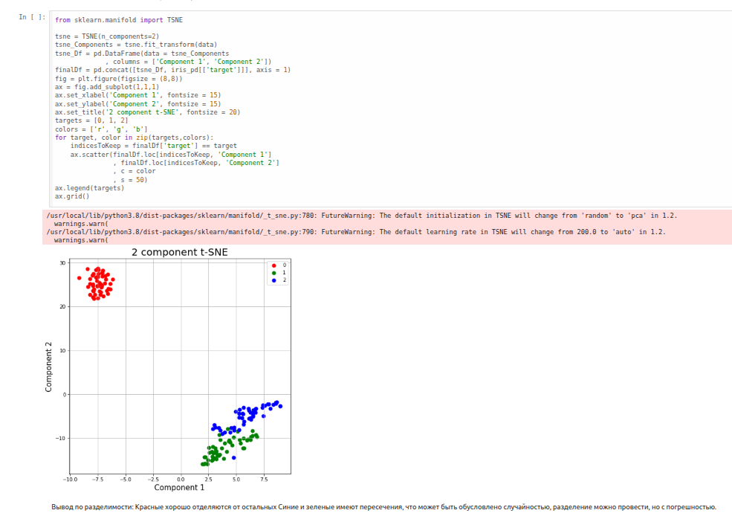

Классификации.
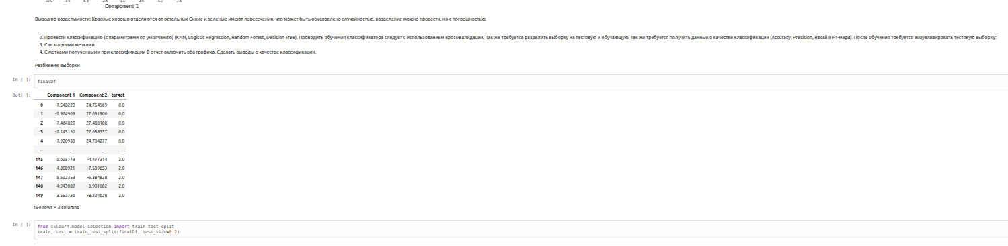
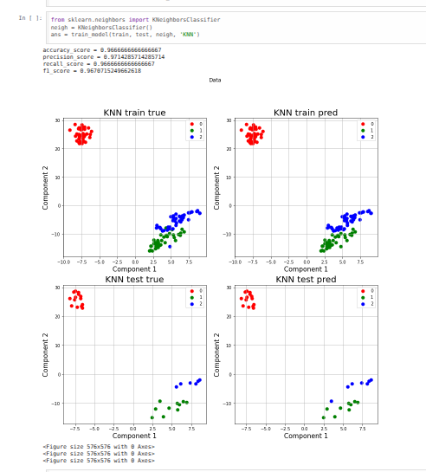

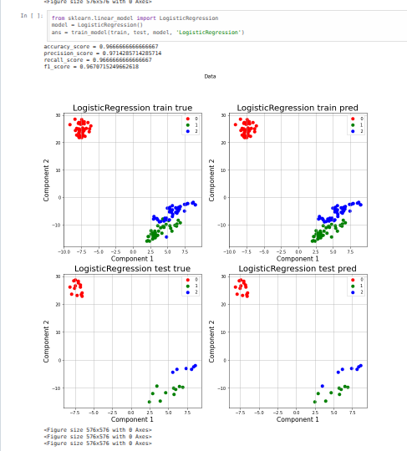

Код:
from sklearn.model_selection import cross_validate def vis_data(X,Y,X_t, Y_t, pred, pred_t, method_name): pred = pd.Series(pred) pred_t = pd.Series(pred_t) fig, ((ax1, ax2), (ax3, ax4)) = plt.subplots(2, 2) fig.suptitle('Data') fig.set_figheight(13) fig.set_figwidth(13) # train original Df = pd.DataFrame(data = X , columns = ['Component 1', 'Component 2']) finalDf = pd.concat([Df, Y], axis = 1) ax1.set_xlabel('Component 1', fontsize = 15) ax1.set_ylabel('Component 2', fontsize = 15) ax1.set_title(method_name + ' train true', fontsize = 20) targets = [0, 1, 2] colors = ['r', 'g', 'b'] for target, color in zip(targets,colors): indicesToKeep = finalDf['target'] == target ax1.scatter(finalDf.loc[indicesToKeep, 'Component 1'] , finalDf.loc[indicesToKeep, 'Component 2'] , c = color , s = 50) ax1.legend(targets) ax1.grid() # train pred Df = pd.DataFrame(data = X.reset_index(drop=True) , columns = ['Component 1', 'Component 2']) Df['target'] = pred fig = plt.figure(figsize = (8,8)) ax2.set_xlabel('Component 1', fontsize = 15) ax2.set_ylabel('Component 2', fontsize = 15) ax2.set_title(method_name + ' train pred', fontsize = 20) targets = [0, 1, 2] colors = ['r', 'g', 'b'] for target, color in zip(targets,colors): indicesToKeep = Df['target'] == target ax2.scatter(Df.loc[indicesToKeep, 'Component 1'] , Df.loc[indicesToKeep, 'Component 2'] , c = color , s = 50) ax2.legend(targets) ax2.grid() # test original Df = pd.DataFrame(data = X_t , columns = ['Component 1', 'Component 2']) finalDf = pd.concat([Df, Y_t], axis = 1) fig = plt.figure(figsize = (8,8)) ax3.set_xlabel('Component 1', fontsize = 15) ax3.set_ylabel('Component 2', fontsize = 15) ax3.set_title(method_name + ' test true', fontsize = 20) targets = [0, 1, 2] colors = ['r', 'g', 'b'] for target, color in zip(targets,colors): indicesToKeep = finalDf['target'] == target ax3.scatter(finalDf.loc[indicesToKeep, 'Component 1'] , finalDf.loc[indicesToKeep, 'Component 2'] , c = color , s = 50) ax3.legend(targets) ax3.grid() # test pred Df = pd.DataFrame(data = X_t.reset_index(drop=True) , columns = ['Component 1', 'Component 2']) Df['target'] = pred_t fig = plt.figure(figsize = (8,8)) ax4.set_xlabel('Component 1', fontsize = 15) ax4.set_ylabel('Component 2', fontsize = 15) ax4.set_title(method_name + ' test pred', fontsize = 20) targets = [0, 1, 2] colors = ['r', 'g', 'b'] for target, color in zip(targets,colors): indicesToKeep = Df['target'] == target ax4.scatter(Df.loc[indicesToKeep, 'Component 1'] , Df.loc[indicesToKeep, 'Component 2'] , c = color , s = 50) ax4.legend(targets) ax4.grid() def my_cross_val(X,Y, model,metrics,cv=4): cv_results = cross_validate(model, X, Y, cv= cv, scoring=metrics) model.predict cv_results return cv_results from sklearn.metrics import accuracy_score from sklearn.metrics import precision_score from sklearn.metrics import recall_score from sklearn.metrics import f1_score def train_model(train,test, model,method_name, metrics = ['accuracy', 'precision_weighted','recall_weighted','f1_weighted'] ): X = train.drop(columns=['target']) Y = train['target'] X_t = test.drop(columns=['target']) Y_t = test['target'] metrics = my_cross_val(X,Y, model, metrics) model.fit(X, Y) answers_t = model.predict(X_t) answers = model.predict(X) metrics_test = [] metrics_test.append(accuracy_score(Y_t, answers_t)) metrics_test.append(precision_score(Y_t, answers_t, average='weighted')) metrics_test.append(recall_score(Y_t, answers_t, average='weighted')) metrics_test.append(f1_score(Y_t, answers_t, average='weighted')) print('accuracy_score = ' + str(metrics_test[0])) print('precision_score = ' + str(metrics_test[1])) print('recall_score = ' + str(metrics_test[2])) print('f1_score = ' + str(metrics_test[3])) vis_data(X, Y, X_t,Y_t,answers,answers_t, method_name ) return model, metrics, metrics_test

